Lori Bolley
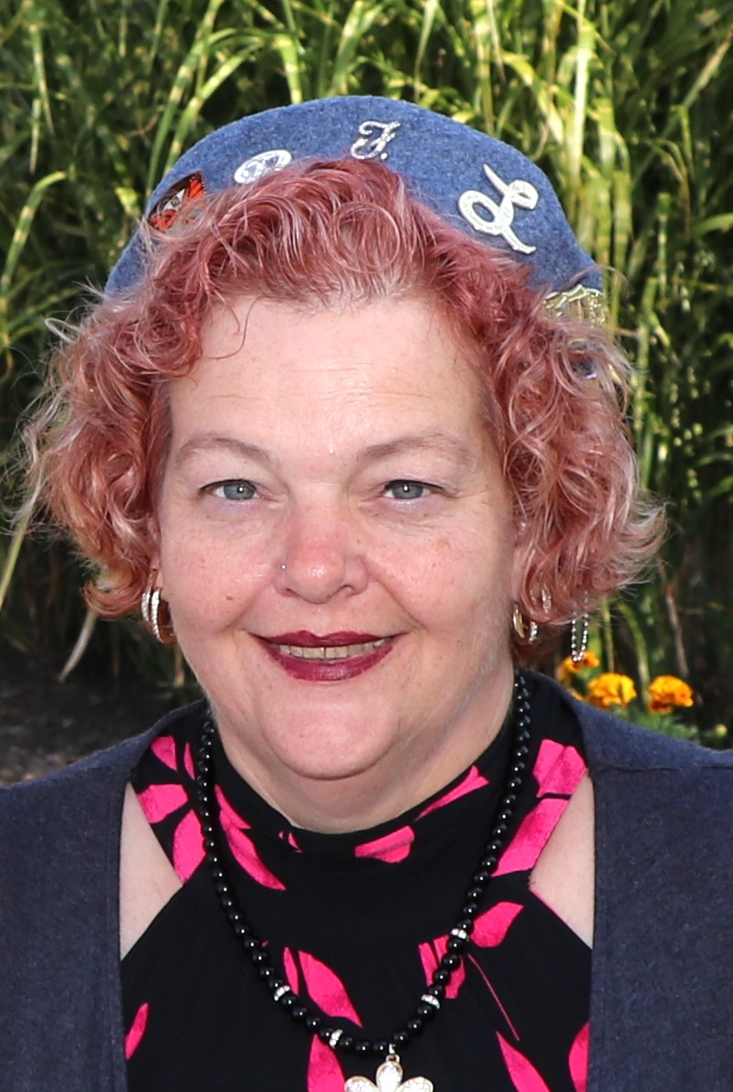
La Presidente Nationale 2023-2024

I was born in Lansing Michigan March 27, 1972. I grew up in the Holt -Mason area and Graduated from Holt High School in 1990. My grandfather, my uncle, and Great Uncle were veterans. I have the blessing of having two daughters Carli and Makaila and two grandchildren Arianna and Antonio
In 2008, I visited the Forty et Eight for the first time and met several Voyageurs and La Femmes and started volunteering, waiting tables, cooking specials, cooking banquet meals for functions. All the while just helping where I could. I found my second home at Voiture 946, a second family who welcomed me and my children. They celebrated my graduation from college and asked me to join the LaFemmes in 2010. In 2013 I became the Bar and Kitchen Manager for Voiture 946.
In 2015 my life would again take a turn as my company downsized and I found a new career with the City of Lansing as an Accounting and Operations Specialist, I have worked my way through the positions there. Currently I am the Senior Office Administrator for the Operations and Maintenance division for the City of Lansing and am still am Bar and Kitchen Manager for Voiture 946.
I joined Cabane 946 in 2010. I have served the Locale Cabane as several chairmanships, La Presidente two (2) years, 1st La Sous Presidente two (2) years, Conducteur one (1) year, Garde la Porte one (1) year, La Drapeau one (1) year and am currently serving as La Advocat (5th year) and Trophy and Awards Chairman five (5) years.
I have served Grande Cabane de Michigan as several chairmanships, Grande La Drapeau one (1) year, Grande Garde de la Porte one (1) year, Grande Conducteur on year, Grande 2nd La Sous Presidente one (1) year, Grande 1st La Sous Presidente one (1) year, Grande La Presidente five (5) years and currently am serving as Grande Commissaire Intendante.
I have served Nationale as Aide de Femme two (2) years, Nationale Ritual Chairman one (1) year, Nationale L Drapeau one (1) year, Nationale La Sous Presidente two (2) years, Nationale La Aumonier one (1) year, Nationale La Garde La Porte and Rules and Order Chairman one (1) year and am currently serving as La Presidente Nationale.
In the minimum spare time that I have, I love to travel, go to the beach, read, and help where I can.

